**SECTION A**

1. Name any one inter-territorial lake in Africa.

.......................................................................................................................

2. Why are babies given birth certificates after being born in hospitals?

.......................................................................................................................

3. In which way is a school nurse important to school children?

.......................................................................................................................

4. State one way people use waterbodies to earn a living.

.......................................................................................................................

5. Why is a place called Bigobyamugenyi economically important to Uganda?

.......................................................................................................................

6. What evidence shows that the Portuguese once lived at the East African coast?

.......................................................................................................................

7. Name the country that Benjamin Nnamdi Azikiwe led to independence.

.......................................................................................................................

8. State any one way water bills can be reduced at home.

.......................................................................................................................

9. Mention any one way in which the early people protected themselves against wild animals.

.......................................................................................................................

10. How can soil erosion be controlled in the school compound?

.......................................................................................................................

11. Why is land said to be the most important economic resource?

.......................................................................................................................

12. Mention the liberation movement that fought for the independence of Mozambique.

.......................................................................................................................

13. Name the chief cash crop of Uganda.

.......................................................................................................................

14. Suggest one way a P.7 candidate can protect himself or herself from child abuse.

.......................................................................................................................

15. In which way is a market important to a potato farmer?

.......................................................................................................................

16. Mention one practice that can cause a conflict between your school and the neighbouring community.

.......................................................................................................................

17. Give any one role played by grand parents in an extended family.

.......................................................................................................................

18. Why is Nkrumah remembered in the history of the OAU?

.......................................................................................................................

19. How does climate affect people’s way of building?

.......................................................................................................................

20. Why is it not advisable to transport tomatoes from Uganda to Germany using water transport?

.......................................................................................................................

21. In which way are wattle trees important to the leather industry?

.......................................................................................................................

22. Which system of governance is used in most African countries today?

.......................................................................................................................

23. State any one duty of the secretary General of the East African Community?

.......................................................................................................................

24. Mention any one activity done by farmers during the dry season.

.......................................................................................................................

25. Write down one act that can lead to insecurity in a home.

.......................................................................................................................

26. Why do most rift valley lakes have salty water?

.......................................................................................................................

27. State any one way the government can increase on its revenue collection.

.......................................................................................................................

28. In which way can a forest cause insecurity in an area.

.......................................................................................................................

29. Why was the Trans-Atlantic trade also called the Triangular trade?

.......................................................................................................................

30. Mention one way some leaders show qualities of poor leadership.

.......................................................................................................................

31. How do warm ocean currents influence climate?

.......................................................................................................................

32. Why did most Nilotes change to mixed farming when they reached East Africa?

.......................................................................................................................

33. State any one duty of a president in a country.

.......................................................................................................................

34. What does the yellow colour of the Uganda National Flag stand for?

.......................................................................................................................

35. Name the Pan-Africanist from USA who encouraged Africans to go for higher education for progress.

.......................................................................................................................

**For questions 36-40, answer Either Christianity OR Islam but not both alternatives in a number.**

36. Either: Why was Jesus Christ baptised yet He never had the original sin?

.......................................................................................................................

Or: Why do Muslims circumcise their male children?

.......................................................................................................................

37. Either: State the meaning of the word parable.

.......................................................................................................................

Or: State the meaning of the word hadith.

.......................................................................................................................

38. Either: Why is a priest or pastor important during mass or church service?

.......................................................................................................................

Or: Why is an imam important during Juma prayer.

.......................................................................................................................

39. Either: State any one duty of the Uganda Joint Christian Council .(UJCC)

.......................................................................................................................

Or: State any one duty of the Uganda Muslim Supreme Council.(UMSC)

.......................................................................................................................

40. Either: Why are Christians advised to repent whenever they sin?

.......................................................................................................................

Or: Why are Muslims encouraged to repent whenever they sin?

.......................................................................................................................

**SECTION B**

41a) State any two challenges that are faced by landlocked countries today.

(i) .....................................................................................................................

(ii) ....................................................................................................................

b) Give two ways how landlocked countries in Africa have tried to solve of the problem they face.

(i) .....................................................................................................................

(ii) ....................................................................................................................

42a) What was the Great Trek?

.......................................................................................................................

.......................................................................................................................

b) State any one cause of the Great Trek.

.......................................................................................................................

c) Give any two results of the Great Trek in South Africa.

(i) .....................................................................................................................

(ii) ....................................................................................................................

43a) Name any two rivers in Africa that are used for large scale irrigation.

(i) .....................................................................................................................

(ii) ....................................................................................................................

b) Give any two advantages of using irrigation in farming.

(i) .....................................................................................................................

(ii) ....................................................................................................................

44a) Give two reasons why the Portuguese were interested in conquering the East African coast.

(i) .....................................................................................................................

(ii) ....................................................................................................................

b) Identify any two positive results of the Portuguese rule at the East African coast between 1500 and 1700.

(i) .....................................................................................................................

(ii) ....................................................................................................................

**45. Study the map of Africa below and answer the questions that follow.**

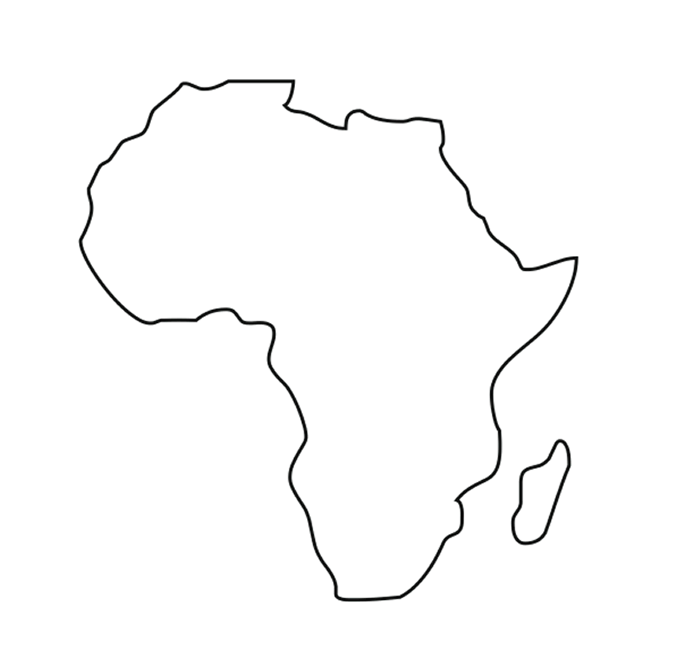 **M**



**Y**



**P** **K**



a) Identify the water passage marked with letter M.

.......................................................................................................................

b) Which ocean current is marked K?

.......................................................................................................................

c) Name the continent marked Y.

.......................................................................................................................

d) Which economic growing united countries in the region marked P?

.......................................................................................................................

46a) State any two challenges facing the tourism industry in East Africa.

(i) .....................................................................................................................

(ii) ....................................................................................................................

b) Suggest the possible solutions to each of the problems you have stated in (a) above.

(i) .....................................................................................................................

(ii) ....................................................................................................................

47a) Give two reasons why most people in Uganda practice subsistence farming.

(i) .....................................................................................................................

(ii) ....................................................................................................................

b) State any two advantages of mixed farming to a farmer.

(i) .....................................................................................................................

(ii) ....................................................................................................................

48a) Why is a multi-party system preferred to be used by most African countries today?

(i) .....................................................................................................................

(ii) ....................................................................................................................

b) Mention any two problems faced by multi-party and electoral systems in Africa today.

(i) .....................................................................................................................

(ii) ....................................................................................................................

**49. Study the table below and answer the questions that follow.**

|  |  |  |  |  |  |  |  |  |  |  |  |  |
| --- | --- | --- | --- | --- | --- | --- | --- | --- | --- | --- | --- | --- |
| Month | J | F | M | A | M | J | J | A | S | O | N | D |
| Rainfall (mm) | 75 | 90 | 190 | 185 | 175 | 90 | 80 | 100 | 200 | 180 | 120 | 95 |
| Temperature(0c) | 22 | 23 | 27 | 26 | 26 | 24 | 22 | 23 | 28 | 26 | 25 | 23 |

a) Why is the above area good for growing perennial crops?

.......................................................................................................................

b) Mention one country in Africa that experience such a type of climate.

.......................................................................................................................

c) What is the relationship between rainfall and temperature in the above station?

.......................................................................................................................

d) Calculate the temperature range for the above station.

50. a) How does Lake Victoria promote Inter-territorial trade?

.......................................................................................................................

b) Give any one characteristic of Lake Victoria as a basin lake.

.......................................................................................................................

c) Why are there many people living around the shores of Lake Victoria?

.......................................................................................................................

d) Name one inland port on Lake Victoria in Tanzania.

.......................................................................................................................

**For questions 36-40, answer Either Christianity OR Islam but not both alternatives in a number.**

51. Either: a) Why is River Jordan important in Christianity?

.......................................................................................................................

b) What role did John the Baptist play in the salvation of man?

.......................................................................................................................

c) Give any two strange things that happened when Jesus Christ was baptised.

(i) .....................................................................................................................

(ii) ....................................................................................................................

Or: How were the following people important in the life of prophet Muhammed (PUH)?

(i) Halimah. .........................................................................................................

(ii) Khadijah..........................................................................................................

b) Give any two things that happened when prophet Muhammed died.

(i) .....................................................................................................................

(ii) ....................................................................................................................

52. Either: a) What is reconciliation?

.......................................................................................................................

.......................................................................................................................

b) State any one traditional way of reconciliation.

.......................................................................................................................

c) Give any two importance of reconciliation.

(i) .....................................................................................................................

(ii) ....................................................................................................................

Or: a) What is reconciliation?

.......................................................................................................................

.......................................................................................................................

b) State any one modern way of reconciliation.

.......................................................................................................................

c) Give any two importance of reconciliation.

(i) .....................................................................................................................

(ii) ....................................................................................................................

53. Either: a) Name two types of marriages accepted in Uganda today.

(i) .....................................................................................................................

(ii) ....................................................................................................................

b) Give two reasons why mature Christians marry.

(i) .....................................................................................................................

(ii) ....................................................................................................................

Or: a) Name two types of marriages accepted in Uganda today.

(i) .....................................................................................................................

(ii) ....................................................................................................................

b) Give two reasons why mature Muslims marry.

(i) .....................................................................................................................

(ii) ....................................................................................................................

45. Either: a) Identify any two holy places that Christians visit during pilgrimage.

(i) .....................................................................................................................

(ii) ....................................................................................................................

b) Mention two reasons why Christians visit holy places.

(i) .....................................................................................................................

(ii) ....................................................................................................................

Or: a) Identify any two holy places in Mecca and Medina Muslims visit during Hijja.

(i) .....................................................................................................................

(ii) ....................................................................................................................

b) Mention two reasons why Muslims perform Hijja.

(i) .....................................................................................................................

(ii) ....................................................................................................................

55. Either: a) Give any two roles of religious leaders in Christianity.

(i) .....................................................................................................................

(ii) ....................................................................................................................

b) State two ways how Christians can help religious leaders to do their work.

(i) .....................................................................................................................

(ii) ....................................................................................................................

Or: a) Give any two roles of religious leaders in Islam.

(i) .....................................................................................................................

(ii) ....................................................................................................................

b) State two ways how Muslims can help religious leaders to do their work.

(i) .....................................................................................................................

(ii) ....................................................................................................................

**END**

**“WISH YOU AN ENJOYABLE TOUR TO WESTERN UGANDA”**